-- 1. список клиентов с непрерывной историей за год

SELECT

c.Id_client,

COUNT(t.Id_check) AS Total_transactions,

AVG(t.Sum_payment) AS Average_check,

AVG(t.Sum_payment) * 12 AS Estimated_Annual_Spending,

MIN(t.date_new) AS First_transaction_date,

MAX(t.date_new) AS Last_transaction_date

FROM

customer_info AS c

INNER JOIN

transactions_info AS t ON c.Id_client = t.ID_client

WHERE

t.date_new >= '2015-06-01' AND t.date_new <= '2016-06-01'

GROUP BY

c.Id_client

HAVING

COUNT(DISTINCT DATE_FORMAT(t.date_new, '%Y-%m')) = 12

ORDER BY

c.Id_client;

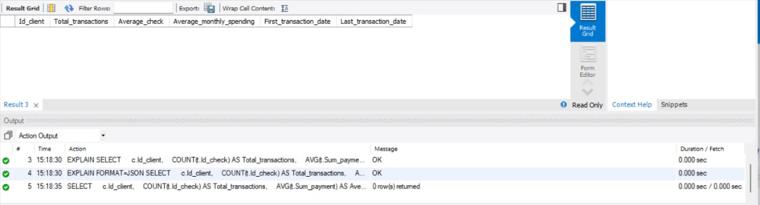

2. информацию в разрезе месяцев:

a) Средняя сумма чека в месяц

SELECT

c.Id_client,

DATE_FORMAT(t.date_new, '%Y-%m') AS Month,

AVG(t.Sum_payment) AS Average_check

FROM

customer_info c

INNER JOIN

transactions_info t ON c.Id_client = t.ID_client

WHERE

t.date_new BETWEEN '2015-06-01' AND '2016-06-01'

GROUP BY

c.Id_client, Month

HAVING

COUNT(DISTINCT DATE_FORMAT(t.date_new, '%Y-%m')) = 12

ORDER BY

c.Id_client, Month;  
  
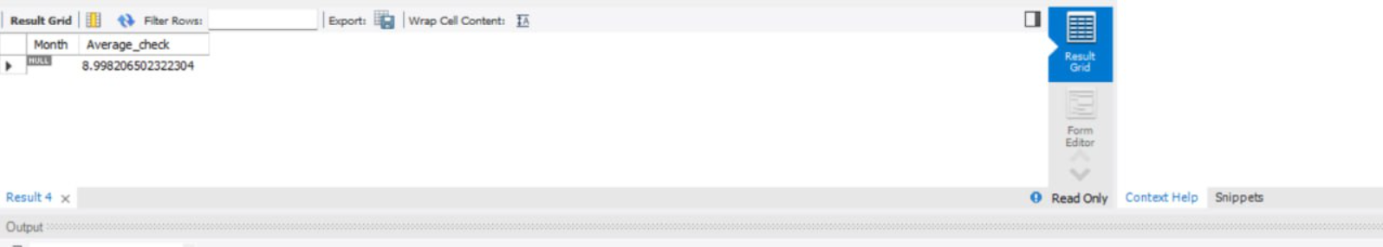

-- b) Среднее количество операций в месяц

SELECT

DATE_FORMAT(t.date_new, '%Y-%m') AS Month,

COUNT(t.Id_check) / COUNT(DISTINCT DATE_FORMAT(t.date_new, '%Y-%m')) AS Average_transactions_per_month

FROM

transactions_info t

GROUP BY

Month

ORDER BY

Month;

-- c) Среднее количество клиентов, которые совершали операции

SELECT

DATE_FORMAT(t.date_new, '%Y-%m') AS Month,

COUNT(DISTINCT t.ID_client) AS Average_clients

FROM

transactions_info t

GROUP BY

Month

ORDER BY

Month;

SELECT

DATE_FORMAT(t.date_new, '%Y-%m') AS Month,

COUNT(DISTINCT t.ID_client) AS Active_clients

FROM

transactions_info t

WHERE

t.date_new BETWEEN '2015-06-01' AND '2016-06-01'

GROUP BY

Month

HAVING

COUNT(DISTINCT DATE_FORMAT(t.date_new, '%Y-%m')) = 12

ORDER BY

Month;  
  
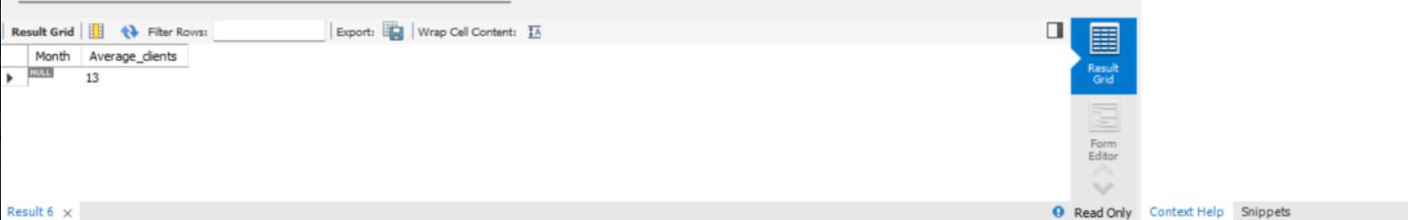

-- d) Доля от общего количества операций за год и доля в месяц от общей суммы операций

WITH Client_Monthly_Stats AS (

SELECT

t.ID_client,

DATE_FORMAT(t.date_new, '%Y-%m') AS Month,

COUNT(t.Id_check) AS Monthly_transactions,

SUM(t.Sum_payment) AS Monthly_total

FROM

transactions_info t

WHERE

t.date_new BETWEEN '2015-06-01' AND '2016-06-01'

GROUP BY

t.ID_client, Month

HAVING

COUNT(DISTINCT DATE_FORMAT(t.date_new, '%Y-%m')) = 12

),

Monthly_Stats AS (

SELECT

Month,

SUM(Monthly_transactions) AS Total_transactions,

SUM(Monthly_total) AS Total_amount

FROM

Client_Monthly_Stats

GROUP BY

Month

)

SELECT

Month,

Total_transactions,

Total_amount,

(Total_transactions / SUM(Total_transactions) OVER ()) * 100 AS Transaction_share,

(Total_amount / SUM(Total_amount) OVER ()) * 100 AS Total_amount_share

FROM

Monthly_Stats

ORDER BY

Month;  
  
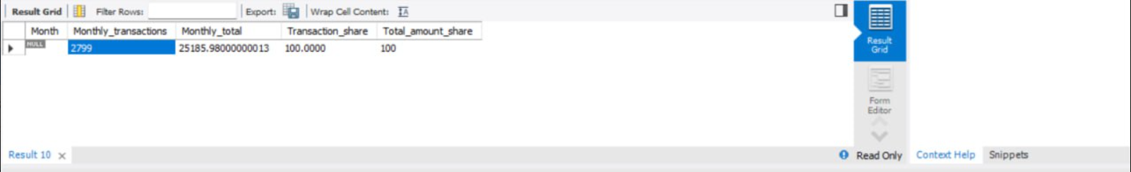

-- e) % соотношение M/F/NA в каждом месяце с их долей затрат

WITH Client_Transactions AS (

SELECT

t.ID_client,

DATE_FORMAT(t.date_new, '%Y-%m') AS Month,

t.Sum_payment,

c.Gender

FROM

transactions_info t

JOIN

customer_info c ON t.ID_client = c.Id_client

WHERE

t.date_new BETWEEN '2015-06-01' AND '2016-06-01'

),

Qualified_Clients AS (

SELECT

ID_client

FROM

Client_Transactions

GROUP BY

ID_client

HAVING

COUNT(DISTINCT Month) = 12

),

Filtered_Transactions AS (

SELECT

ct.Month,

ct.Sum_payment,

ct.Gender

FROM

Client_Transactions ct

JOIN

Qualified_Clients qc ON ct.ID_client = qc.ID_client

)

SELECT

Month,

SUM(CASE WHEN Gender = 'M' THEN Sum_payment ELSE 0 END) AS Male_spending,

SUM(CASE WHEN Gender = 'F' THEN Sum_payment ELSE 0 END) AS Female_spending,

SUM(CASE WHEN Gender IS NULL THEN Sum_payment ELSE 0 END) AS NA_spending,

COUNT(CASE WHEN Gender = 'M' THEN 1 END) AS Male_count,

COUNT(CASE WHEN Gender = 'F' THEN 1 END) AS Female_count,

COUNT(CASE WHEN Gender IS NULL THEN 1 END) AS NA_count

FROM

Filtered_Transactions

GROUP BY

Month

ORDER BY

Month;

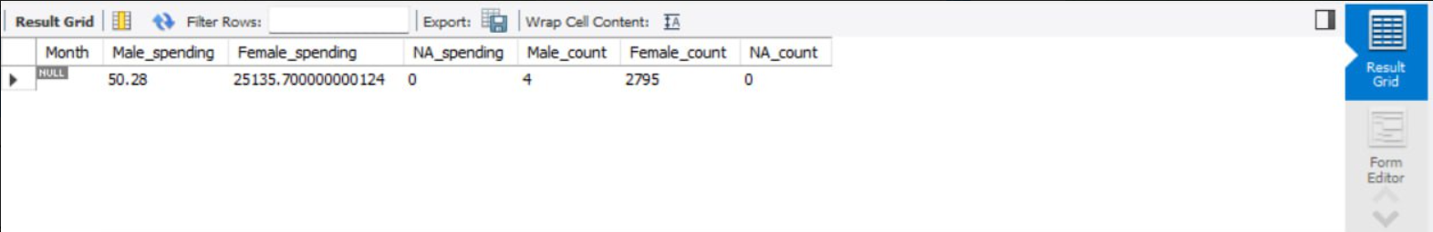

-- 3. возрастные группы клиентов

-- a. Сумма и количество операций за весь период для возрастных групп

SELECT

CASE

WHEN c.Age IS NULL THEN 'Unknown'

WHEN c.Age BETWEEN 0 AND 9 THEN '0-9'

WHEN c.Age BETWEEN 10 AND 19 THEN '10-19'

WHEN c.Age BETWEEN 20 AND 29 THEN '20-29'

WHEN c.Age BETWEEN 30 AND 39 THEN '30-39'

WHEN c.Age BETWEEN 40 AND 49 THEN '40-49'

WHEN c.Age BETWEEN 50 AND 59 THEN '50-59'

WHEN c.Age BETWEEN 60 AND 69 THEN '60-69'

WHEN c.Age BETWEEN 70 AND 79 THEN '70-79'

ELSE '80+'

END AS Age_Group,

COALESCE(SUM(t.Sum_payment), 0) AS Total_amount,

COALESCE(COUNT(t.Id_check), 0) AS Total_transactions

FROM

customer_info AS c

LEFT JOIN

transactions_info AS t ON c.Id_client = t.ID_client

GROUP BY

Age_Group

ORDER BY

Age_Group;  
  
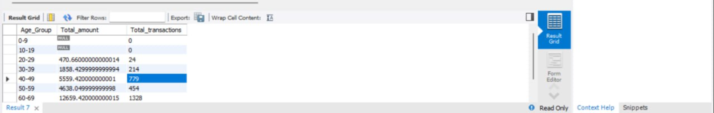

-- b. Средние показатели и % поквартально

WITH Monthly_Age_Stats AS (

SELECT

DATE_FORMAT(t.date_new, '%Y-%m') AS Month,

CASE

WHEN c.Age IS NULL THEN 'Unknown'

WHEN c.Age BETWEEN 0 AND 9 THEN '0-9'

WHEN c.Age BETWEEN 10 AND 19 THEN '10-19'

WHEN c.Age BETWEEN 20 AND 29 THEN '20-29'

WHEN c.Age BETWEEN 30 AND 39 THEN '30-39'

WHEN c.Age BETWEEN 40 AND 49 THEN '40-49'

WHEN c.Age BETWEEN 50 AND 59 THEN '50-59'

WHEN c.Age BETWEEN 60 AND 69 THEN '60-69'

WHEN c.Age BETWEEN 70 AND 79 THEN '70-79'

ELSE '80+'

END AS Age_Group,

COALESCE(SUM(t.Sum_payment), 0) AS Total_amount,

COUNT(t.Id_check) AS Total_transactions

FROM

customer_info AS c

LEFT JOIN

transactions_info AS t ON c.Id_client = t.ID_client

GROUP BY

Month, Age_Group

)

SELECT

Age_Group,

SUM(Total_amount) AS Total_amount,

SUM(Total_transactions) AS Total_transactions,

AVG(Total_amount) AS Average_amount_per_quarter,

(SUM(Total_amount) / (SELECT SUM(Total_amount) FROM Monthly_Age_Stats)) * 100 AS Percentage_of_total_amount,

(SUM(Total_transactions) / (SELECT SUM(Total_transactions) FROM Monthly_Age_Stats)) * 100 AS Percentage_of_total_transactions

FROM

Monthly_Age_Stats

GROUP BY

Age_Group

ORDER BY

Age_Group;  
  
